Student Performance Analysis Using R

No. | Index | Page No.
1 | Introduction | 2
2 | Objectives | 2
3 | Dataset Description | 2
4 | Tools and Technologies | 3
5 | Methodology | 6
6 | Linear Regression Model | 10
7 | Prediction | 11
8 | Result and discussion | 11
9 | Conclusion | 11
10 | Reference | 11
11 | Learning Outcomes | 12

1. Introduction
In today’s data-driven world, analysing student performance is important for improving academic outcomes. This project focuses on analysing student data using the R programming language. The goal is to understand how factors like study hours and attendance affect students' academic performance.
The project uses powerful R packages such as dplyr, tidyr, and ggplot2 for data manipulation, transformation, and visualization.

2. Objectives
- To analyse student performance data
- To explore the relationship between study hours, attendance, and scores
- To perform data cleaning and transformation
- To visualize trends using graphs
- To build a linear regression model for prediction

3. Dataset Description
The dataset used in this project contains information about students, including:
- Student ID
- Gender
- Study Hours
- Attendance (%)
- Math Score
- Science Score
- English Score
The dataset consists of more than 100 entries and is stored in CSV format.

4. Tools and Technologies
- R Programming Language
- RStudio
- Libraries Used:
  - dplyr
  - tidyr
  - ggplot2

4.1 Code

# Load required libraries
library(dplyr) # for data manipulation
library(tidyr) # for reshaping data
library(ggplot2) # for data visualization

# Read CSV file (user selects file manually)
data <- read.csv(file.choose(), header = TRUE)

# View first and last few rows of dataset
head(data)
tail(data)

# -------------------------------
# DATA ANALYSIS USING DPLYR
# -------------------------------

# Calculate average scores by gender
data %>%
group_by(gender) %>% # group data by gender
summarise(
avg_math = mean(math_score), # average math score
avg_science = mean(science_score), # average science score
avg_english = mean(english_score) # average english score
)

# Create a new column: total_score
data <- data %>%
mutate(total_score = math_score + science_score + english_score)

# -------------------------------
# FIND TOP STUDENTS
# -------------------------------

# Display top 5 students based on total score
data %>%
arrange(desc(total_score)) %>% # sort in descending order
head(5)

# -------------------------------
# DATA RESHAPING USING TIDYR
# -------------------------------

# Convert wide format to long format
long_data <- data %>%
pivot_longer(
cols = c(math_score, science_score, english_score), # columns to combine
names_to = "subject", # new column for subject names
values_to = "score" # new column for scores
)

# -------------------------------
# DATA VISUALIZATION USING GGPLOT2
# -------------------------------

# Scatter plot: Study hours vs Total score
ggplot(data, aes(x = study_hours, y = total_score)) +
geom_point(color = "blue") + # plot points
geom_smooth(method = "lm") + # add regression line
labs(title = "Study Hours vs Total Score")

# Bar chart: Average score by subject
long_data %>%
group_by(subject) %>%
summarise(avg_score = mean(score)) %>%
ggplot(aes(x = subject, y = avg_score, fill = subject)) +
geom_bar(stat = "identity") + # create bar chart
theme_minimal()

# Scatter plot: Attendance vs Total score (colored by gender)
ggplot(data, aes(x = attendance, y = total_score, color = gender)) +
geom_point() +
labs(title = "Attendance vs Total Score")

# -------------------------------
# LINEAR REGRESSION MODEL
# -------------------------------

# Build regression model
model <- lm(total_score ~ study_hours + attendance, data = data)

# Display model summary (coefficients, R-squared, etc.)
summary(model)

# -------------------------------
# PREDICTION
# -------------------------------

# Create new data for prediction
new_students <- data.frame(
study_hours = c(2, 4, 6),
attendance = c(70, 85, 95)
)

# Predict total scores for new data
predictions <- predict(model, newdata = new_students)

# Combine input and predicted output
cbind(new_students, predicted_score = predictions)

# -------------------------------
# VISUALIZING REGRESSION
# -------------------------------

# Plot regression line with data
ggplot(data, aes(x = study_hours, y = total_score)) +
geom_point(color = "darkgreen") +
geom_smooth(method = "lm", se = TRUE, color = "red") +
labs(title = "Linear Regression: Study Hours vs Total Score")

# -------------------------------
# ACTUAL VS PREDICTED
# -------------------------------

# Add predicted values to dataset
data$predicted <- predict(model)

# Plot actual vs predicted values
ggplot(data, aes(x = total_score, y = predicted)) +
geom_point(color = "blue") +
geom_abline(slope = 1, intercept = 0, color = "red") + # perfect prediction line
labs(title = "Actual vs Predicted Scores")

5. Methodology

5.1 Data Loading
The dataset was imported into R using the read.csv () function.
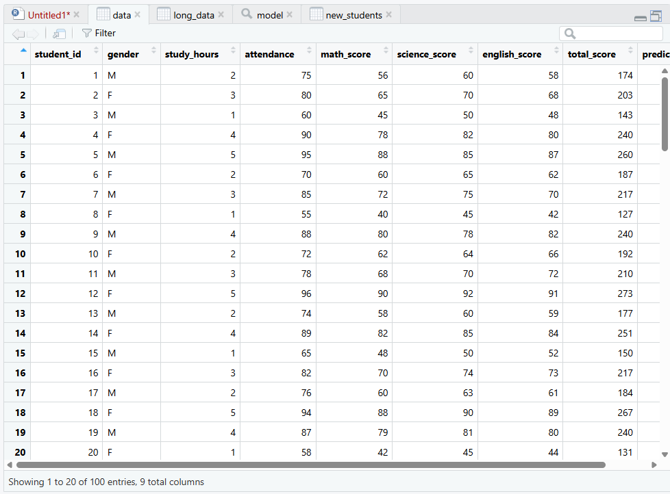

5.2 Data Manipulation
Using dplyr:
- Calculated average scores
- Created a new variable called total_score
- Sorted and filtered data
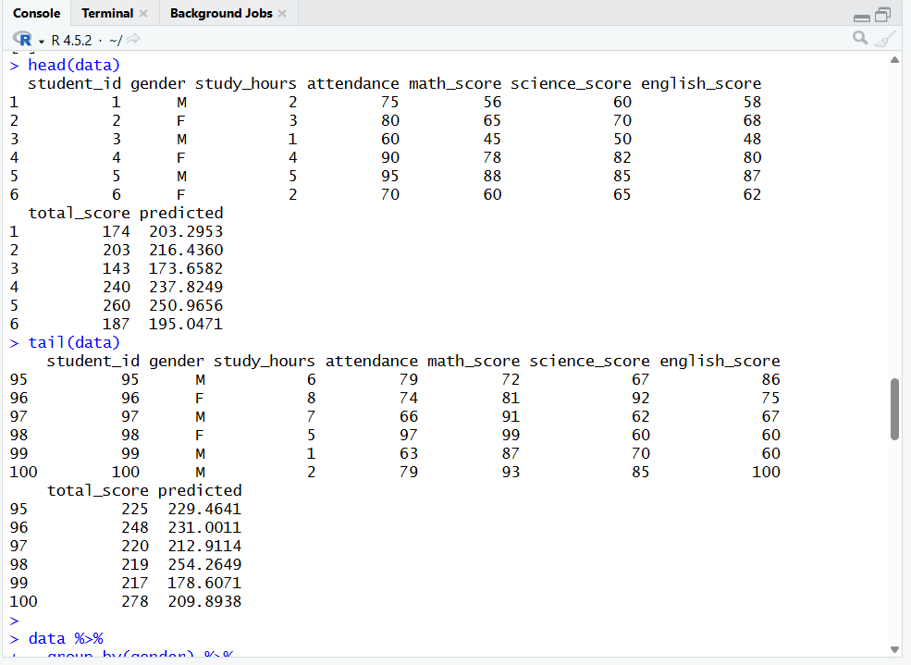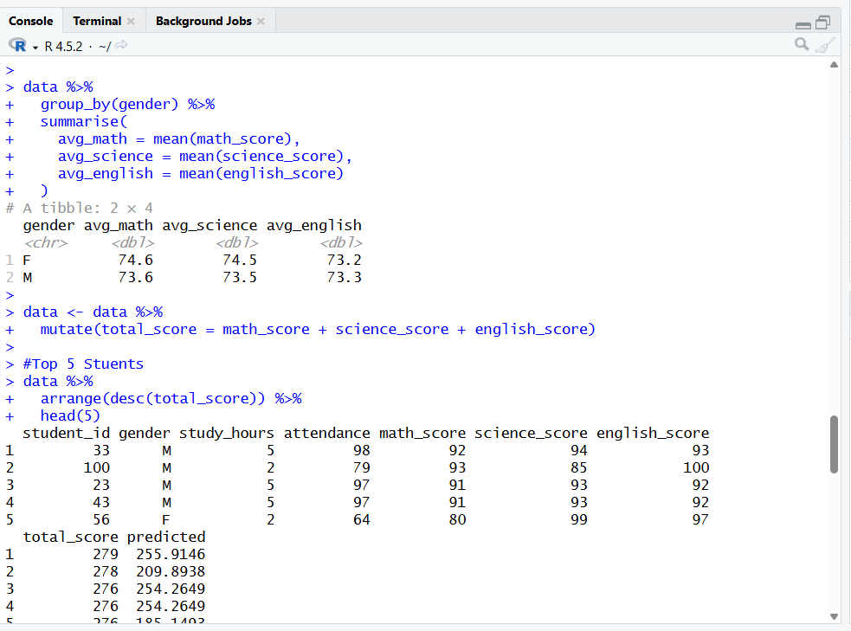

5.3 Data Transformation
Using tidyr:
- Converted data from wide format to long format using pivot_longer()
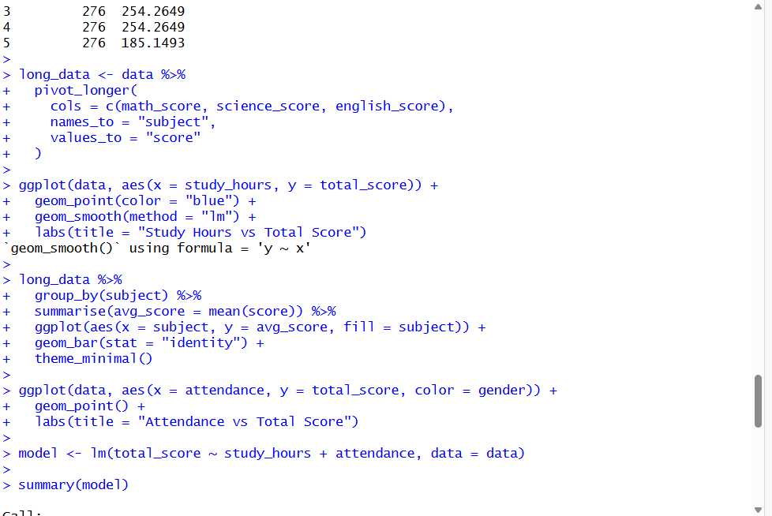

5.4 Data Visualization
Using ggplot2:
- Scatter plots were created to show relationships
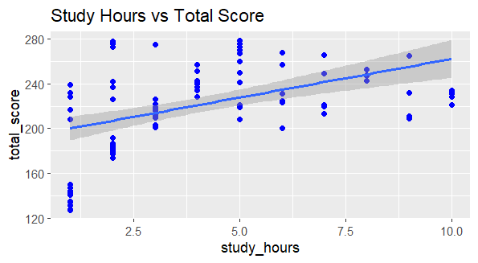
- Bar charts were used to show average scores
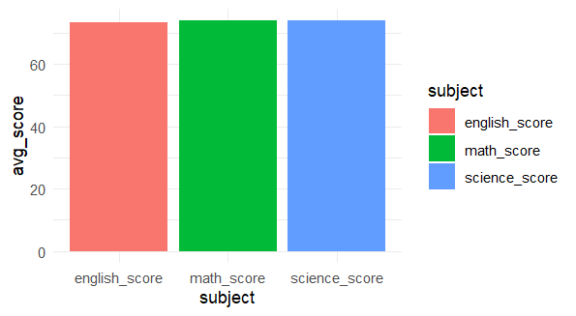
- Regression lines were added for trend analysis
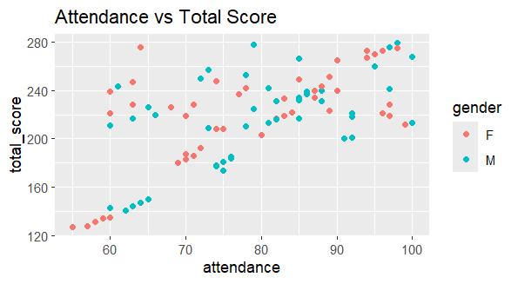

6. Linear Regression Model
A linear regression model was built to predict total_score based on:
- Study Hours
- Attendance
Model formula:
total_score = β0 + β1(study_hours) + β2(attendance)

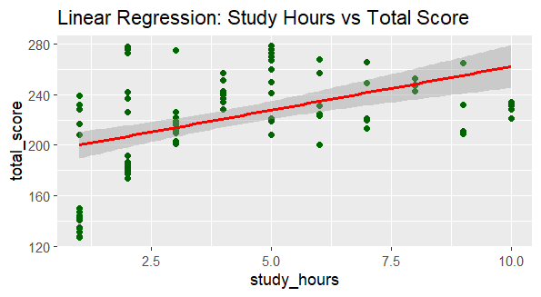
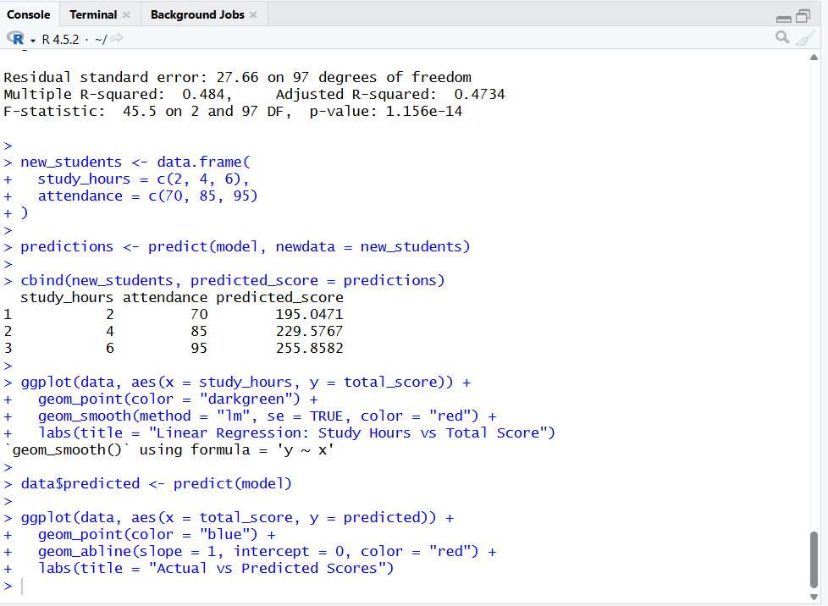

7. Prediction
Predictions were made for new students using the model. This allows estimation of expected performance based on study habits and attendance.
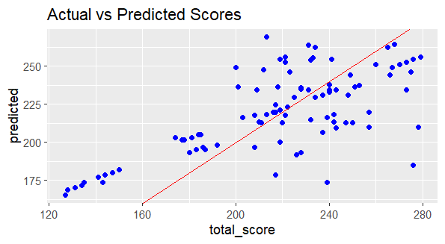

8. Results and Discussion
- Students who study more hours tend to score higher marks
- Attendance has a positive impact on performance
- The regression model showed a strong relationship between variables
- Visualization helped in understanding trends clearly

9. Conclusion
This project successfully demonstrated how R can be used for data analysis and prediction. The use of dplyr, tidyr, and ggplot2 made it easier to manipulate and visualize data.

10. References
- R Documentation
- ggplot2 Documentation
- Online tutorials and resources

11. Learning Outcomes

- After completing this project, the following learning outcomes were achieved:
- Developed an understanding of data analysis using R programming
- Learned how to import and handle CSV datasets in R
- Gained practical experience using dplyr for data manipulation (filtering, grouping, summarizing)
- Understood how to reshape data using tidyr (wide to long format)
- Acquired skills in data visualization using ggplot2 to create meaningful graphs
- Learned how to build and interpret a linear regression model
- Gained knowledge of predictive analysis using regression techniques
- Improved ability to interpret data trends and patterns
- Developed skills to present data insights effectively through plots and summaries
- Enhanced problem-solving and analytical thinking using real-world data

